**BRANCHING AND SHIFTING OPERATIONS**

**LAB # 03**



**Fall 2023**

**CSE-304L Computer Organization and Architecture Lab**

Submitted by: **Ali Asghar**

Registration No.: **21PWCSE2059**

Class Section: **C**

“On my honor, as student of University of Engineering and Technology, I have neither given nor received unauthorized assistance on this academic work.”

Submitted to:

**Dr. Bilal Habib**

Date:

**19th October 2023**

**Department of Computer Systems Engineering**

**University of Engineering and Technology, Peshawar**

**ASSESSMENT RUBRICS COA LABS**

|  |  |  |  |  |
| --- | --- | --- | --- | --- |
| **LAB REPORT ASSESSMENT** | | | | |
| **Criteria** | **Excellent** | **Average** | **Nill** | **Marks Obtained** |
| 1. **Objectives of Lab** | All objectives of lab are properly covered  [Marks 10] | Objectives of lab are partially covered  [Marks 5] | Objectives of lab are not shown  [Marks 0] |  |
| 1. **MIPS instructions with**   **Comments and proper indentations.** | All the instructions are well written with comments explaining the code and properly indented  [Marks 20] | Some instructions are missing are poorly commented code  [Marks 10] | The instructions are not properly written  [Marks 0] |  |
| 1. **Simulation run without error and warnings** | The code is running in the simulator without any error and warnings  [Marks 10] | The code is running but with some warnings or errors.  [Marks 5] | The code is written but not running due to errors  [Marks 0] |  |
| 1. **Procedure** | All the instructions are written with proper procedure  [Marks 20] | Some steps are missing  [Marks 10] | steps are totally missing  [Marks 0] |  |
| 1. **OUTPUT** | Proper output of the code written in assembly  [Marks 20] | Some of the outputs are missing  [Marks 10] | No or wrong output  [Marks 0] |  |
| 1. **Conclusion** | Conclusion about the lab is shown and written  [Marks 20] | Conclusion about the lab is partially shown  [Marks 10] | Conclusion about the lab is not shown[Marks0]  [Marks 0] |  |
| 1. **Cheating** |  |  | Any kind of cheating will lead to 0 Marks |  |
| Total Marks Obtained:__________  Instructor Signature: ______________________ | | | | |

**Task 1:**

Take the 1st number from user. Then take a number to do the operation. (1 corresponds to addition, 2 corresponds to subtraction, 3 for multiplication and 4 for division). Then finally take a 2nd number from a user.

**Code:**

**Output:**

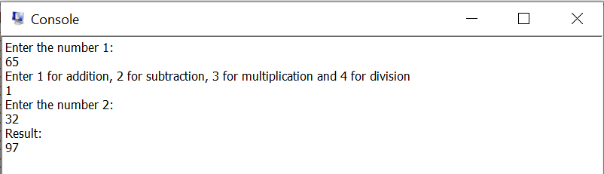

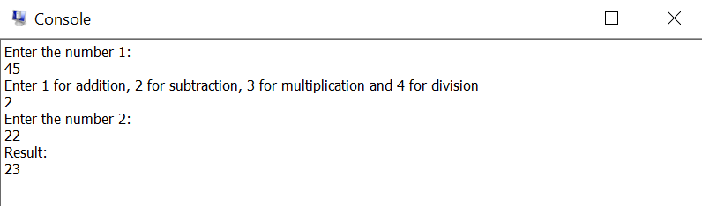

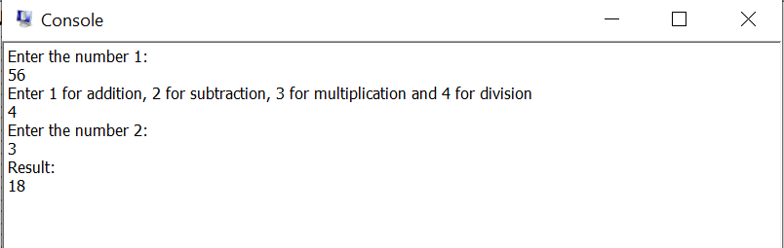

**Task 2 & 3:**

Write a program that’s show the bit position of a number is 0 or 1. (Hint if number is 5 it is represented by 0101 show the 4th bit position is 0, similarly if the user enters 9 then the binary equivalent is 1001. In this case the 4th bit position is 1).

Now toggle the bit find in the previous task if the bit is 1 set it to 0 if it is 0 then set it to 1.

**Code:**

**Output:**

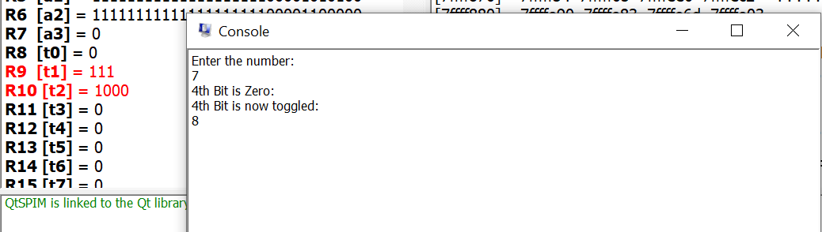

**Task 4:**

Write a program to check a number entered by user is even or odd.

**Code:**

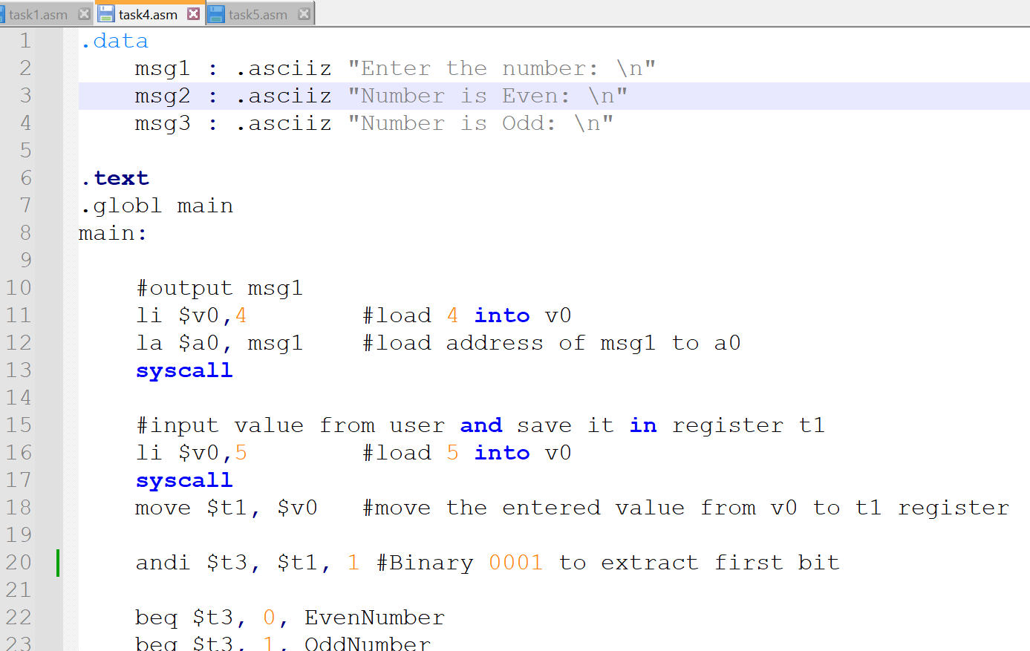

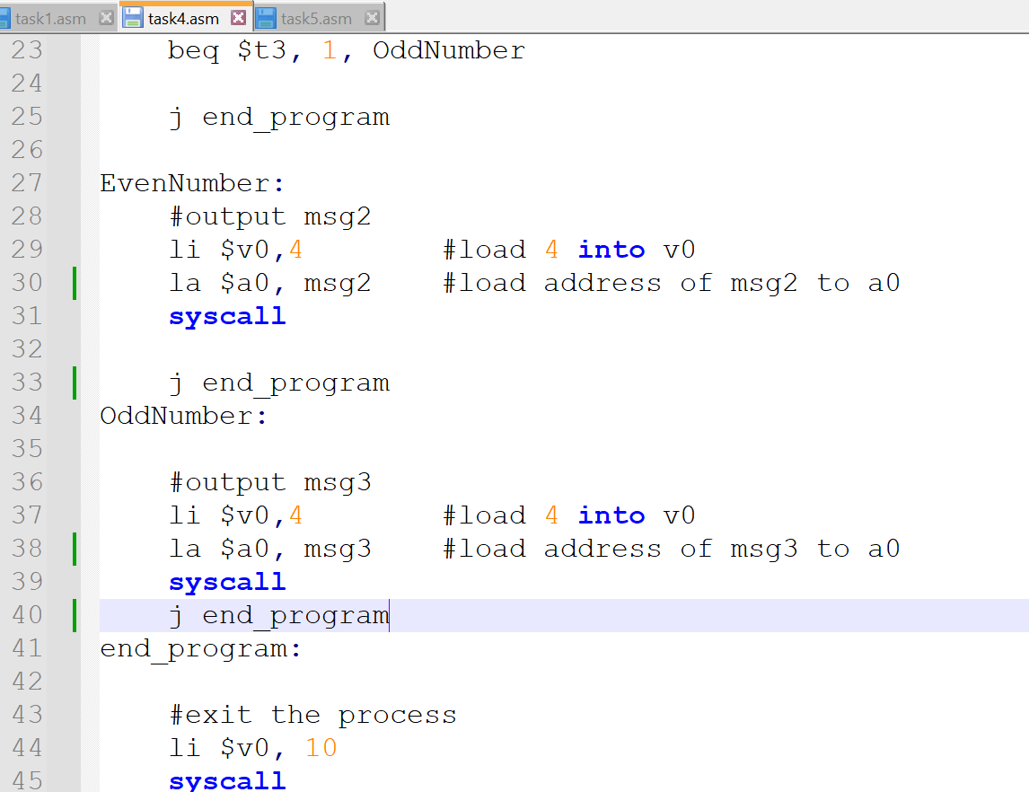

**Output:**

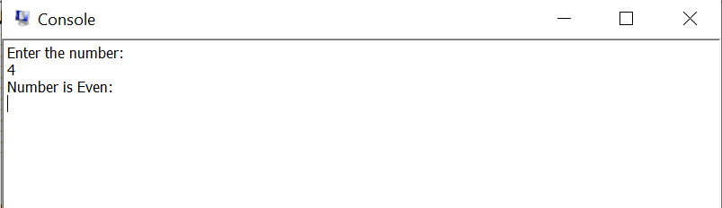

**Task 5:**

Show that shifting left of an even number by 1 position is a multiplication by 2 and shifting right of an even number by 1 position is a division by 2. (Hint: Use sll and srl).

**Code:**

**Output:**

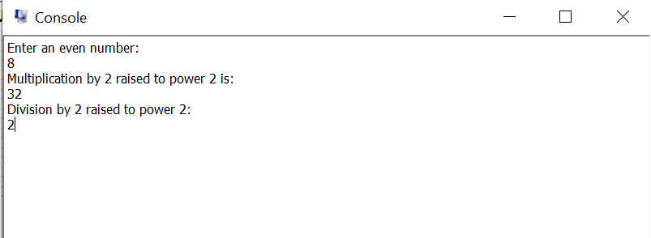

**Conclusion:**

In this lab, I learned about the branching instructions(Control Structures) and bit shifting operations in MIPS Assembly.